Course End Project 1

**Description**

To implement a CI/CD pipeline using AWS services for automating the deployment of a Spring Boot application on Amazon ECS with Docker, integrating CodePipeline, CodeBuild and ECR for seamless updates

1. Fork the Spring Boot project GitHub repository and create an ECR to store the Docker images

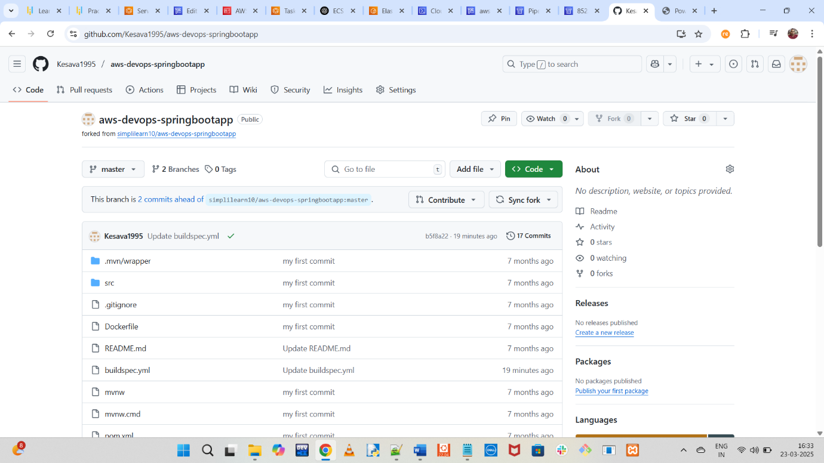

1. Modify the build configuration file in the GitHub repository to include the ECR image URI

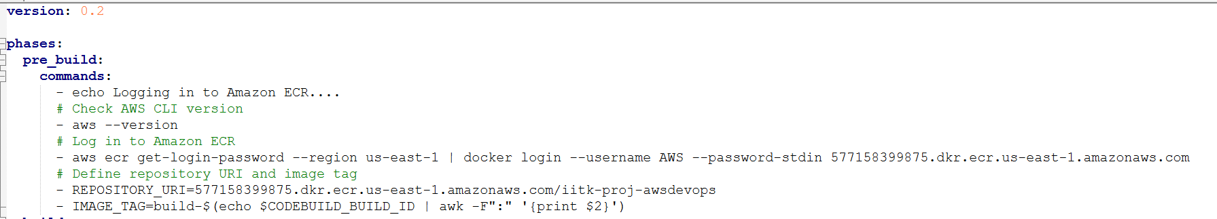

3. Create a CodeBuild project to pull code from the GitHub repository

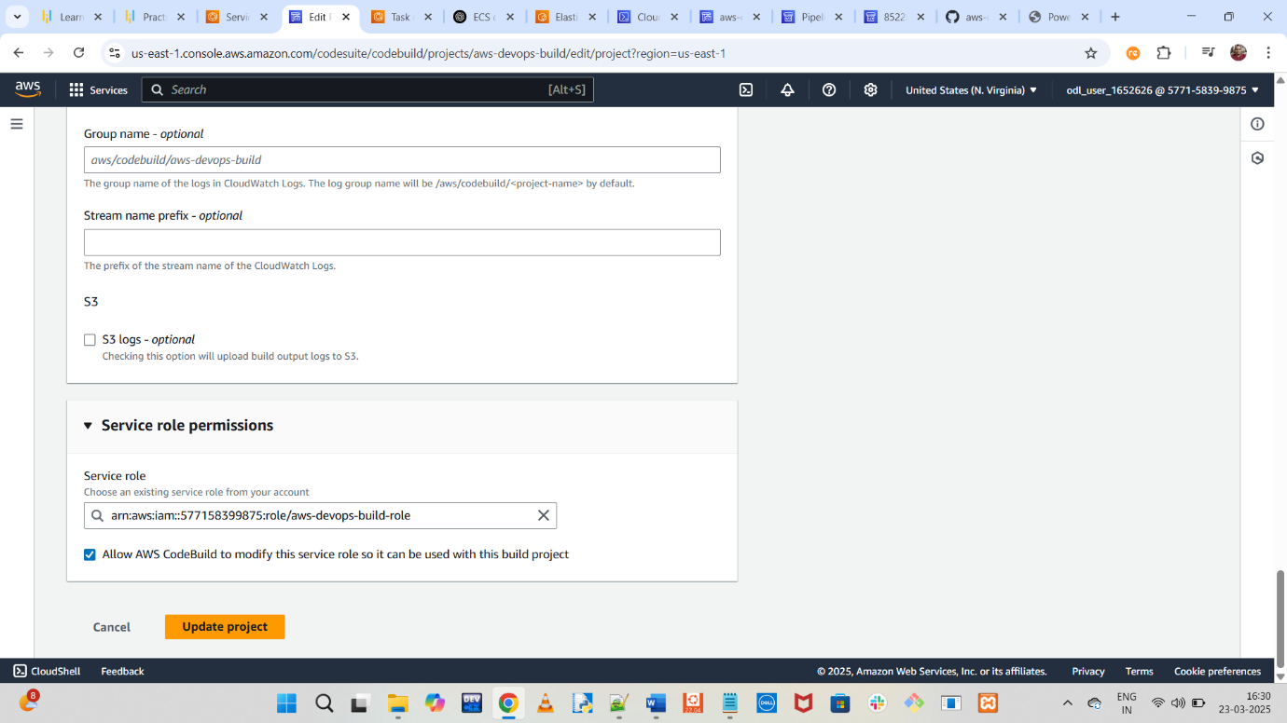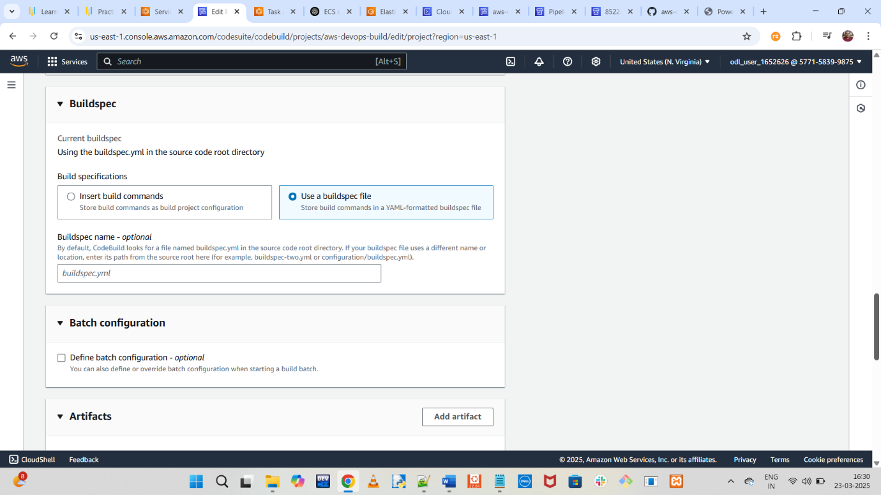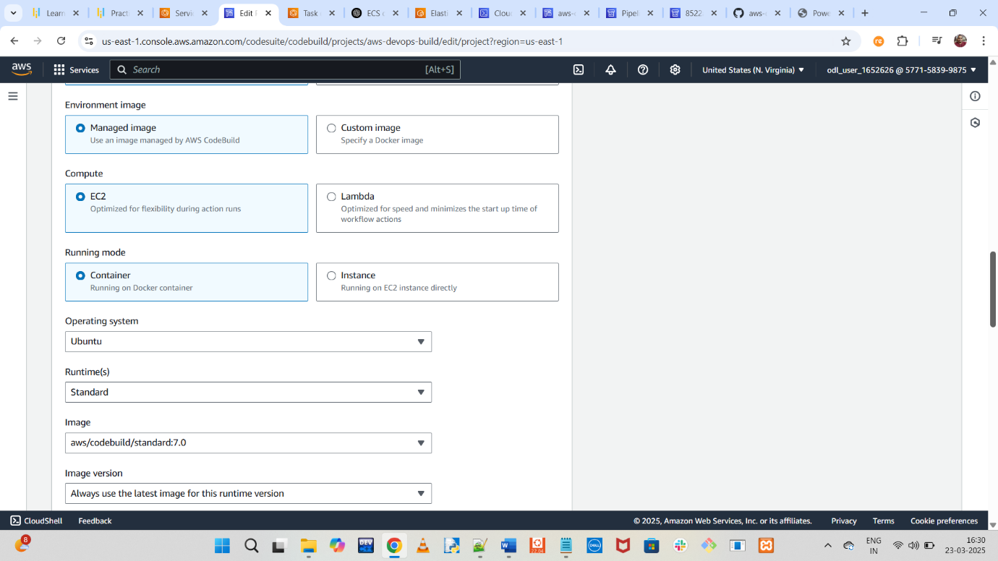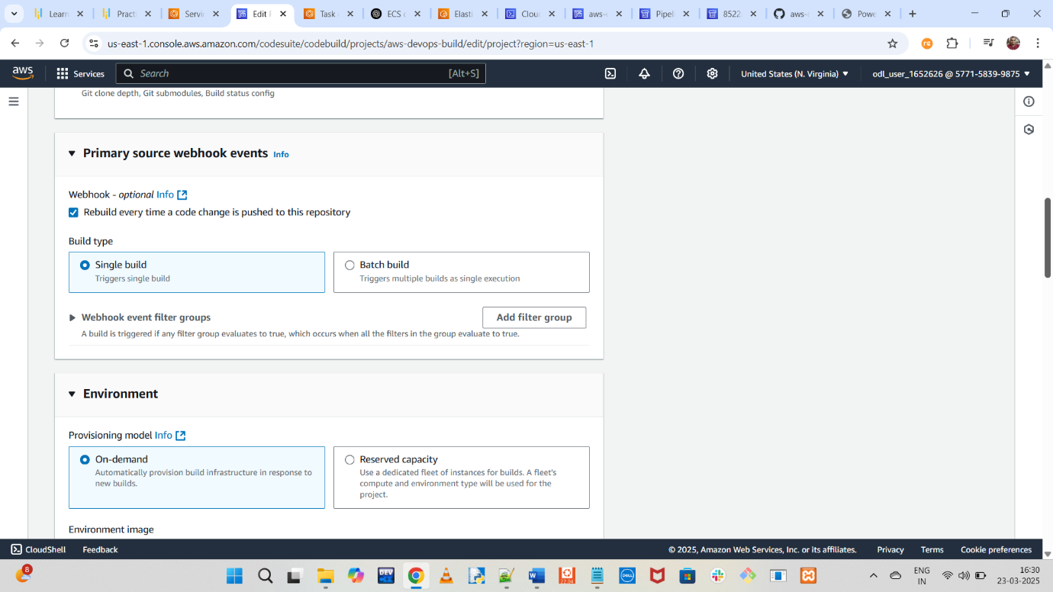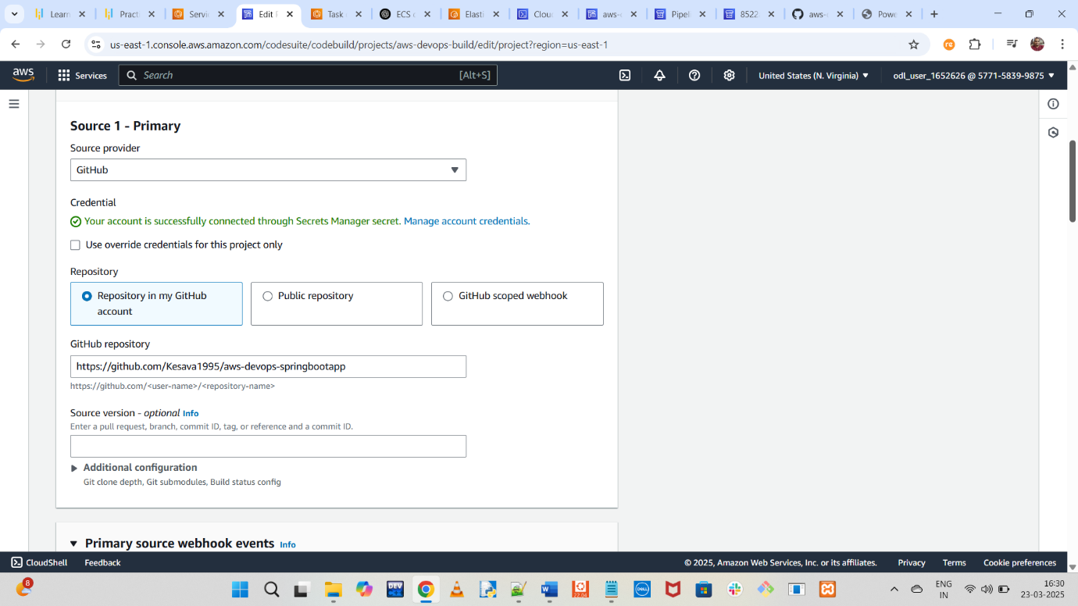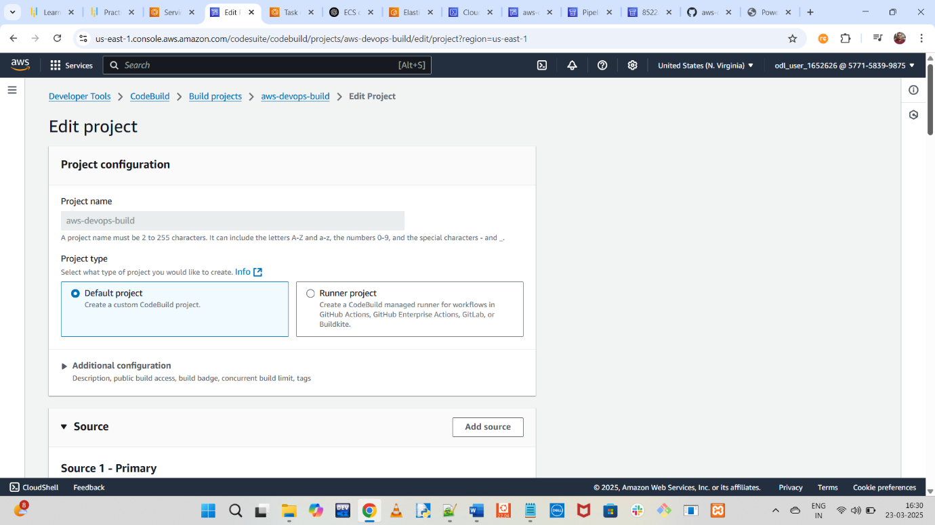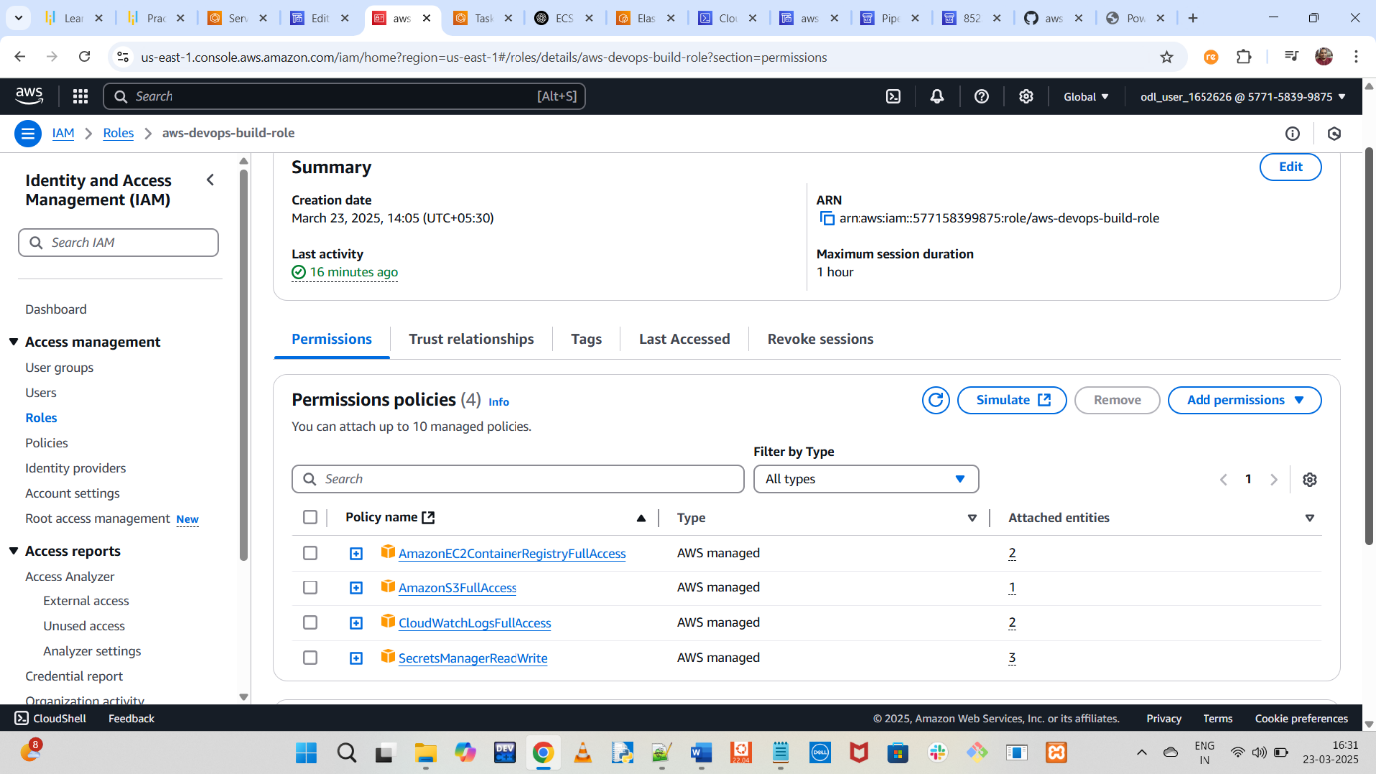

4. Create an ECS cluster using the Fargate launch type and configure an ECS service to run tasks on the cluster 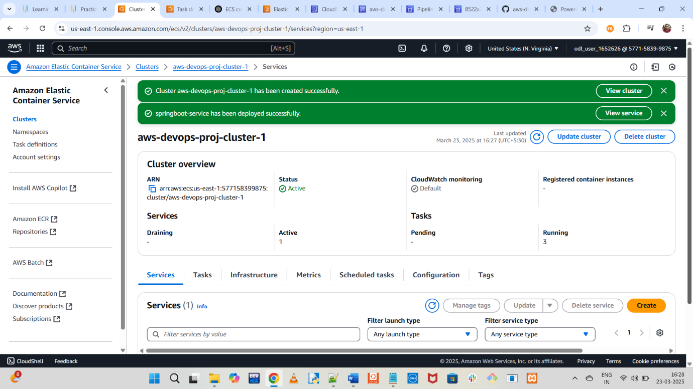 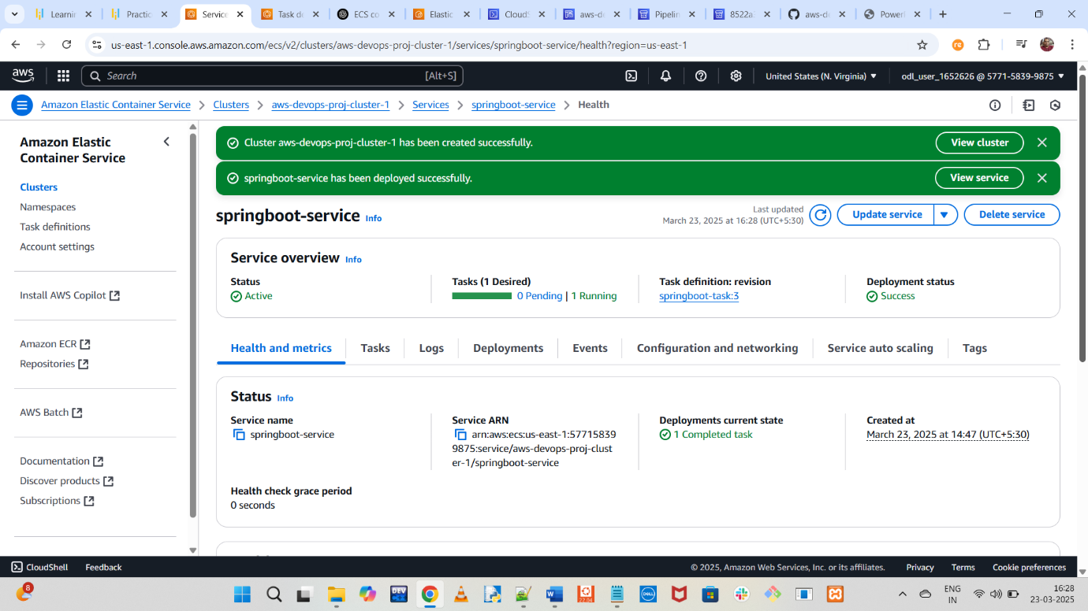

5. Deploy the application

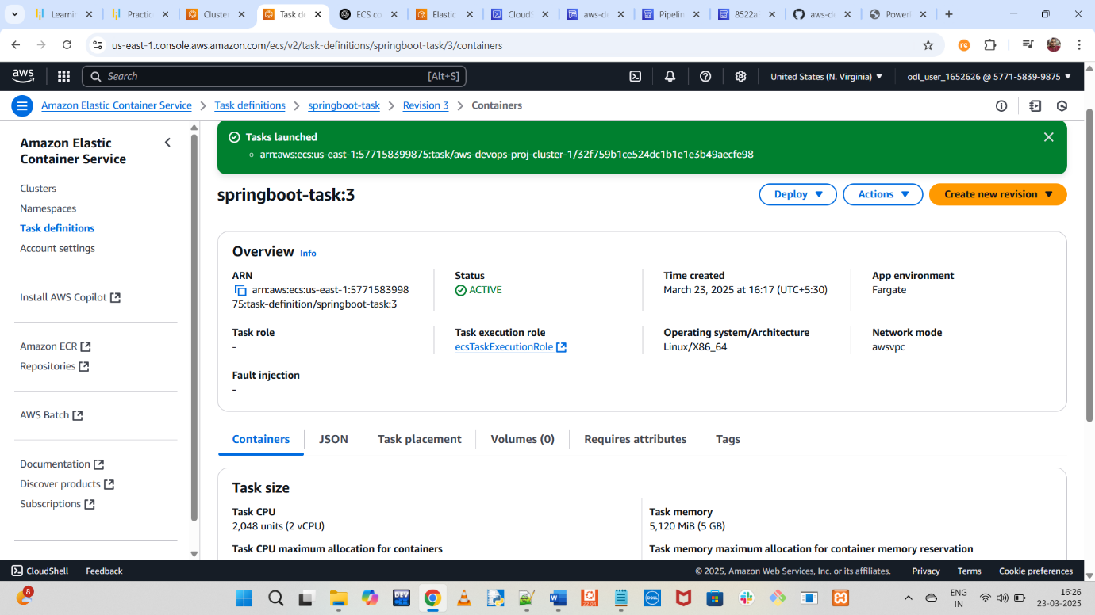

6. Configure CodePipeline to trigger on GitHub changes, integrating CodeBuild and ECS for automated deployment

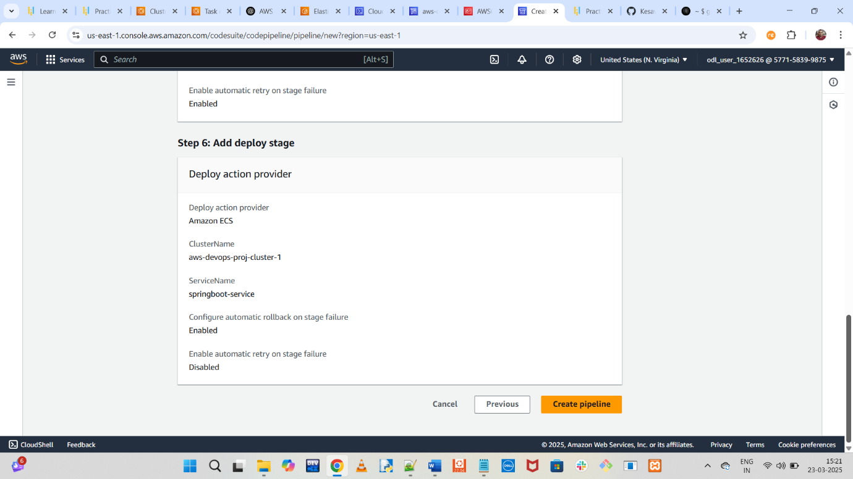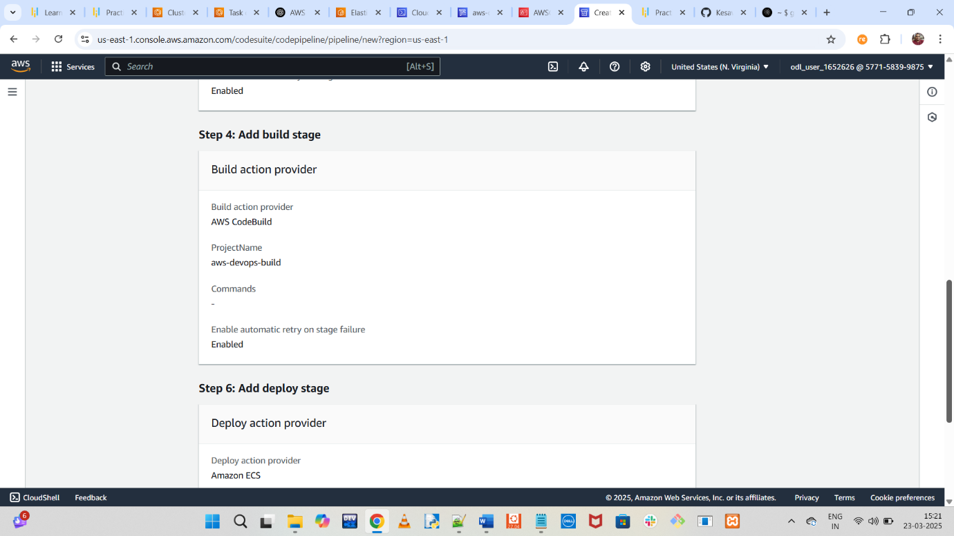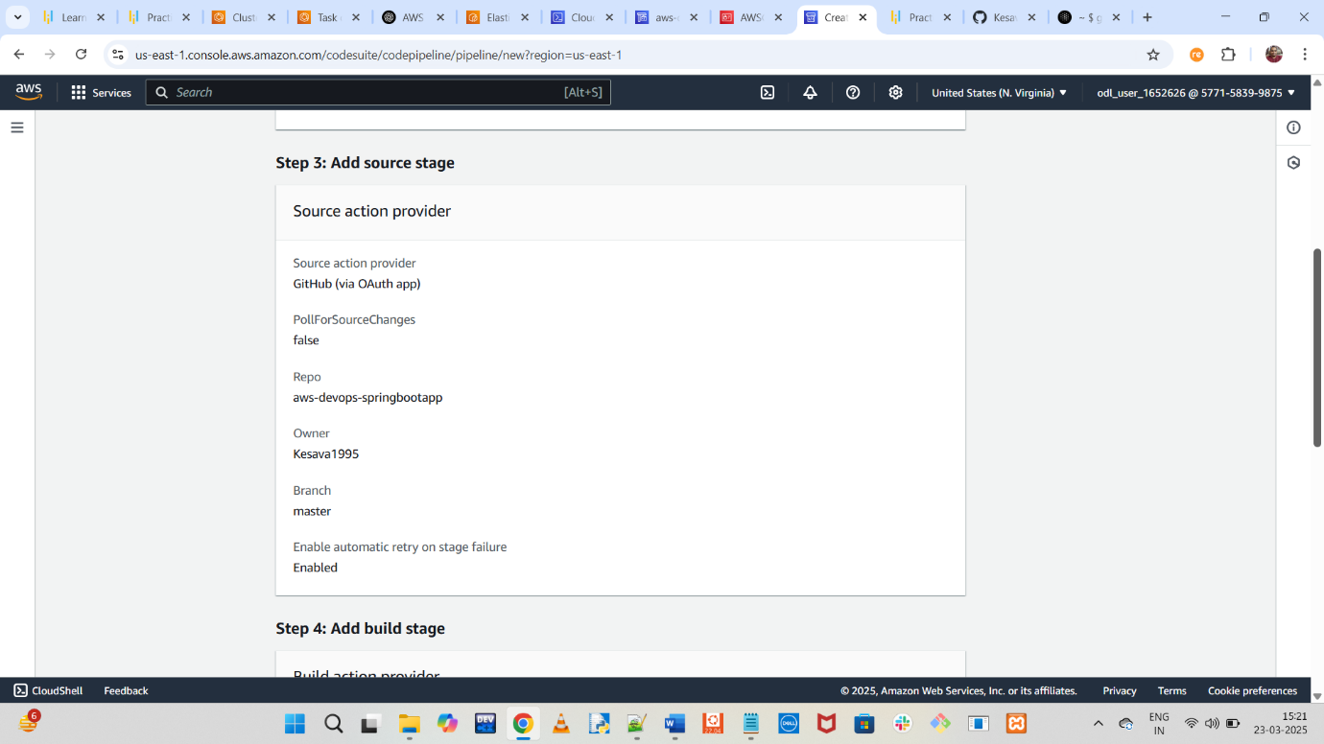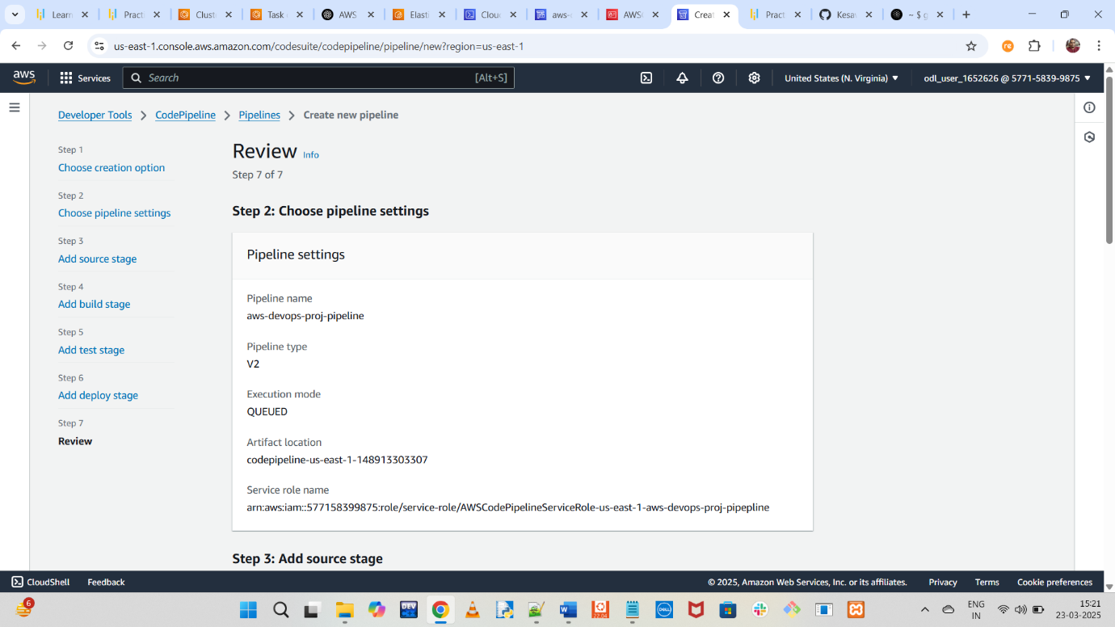 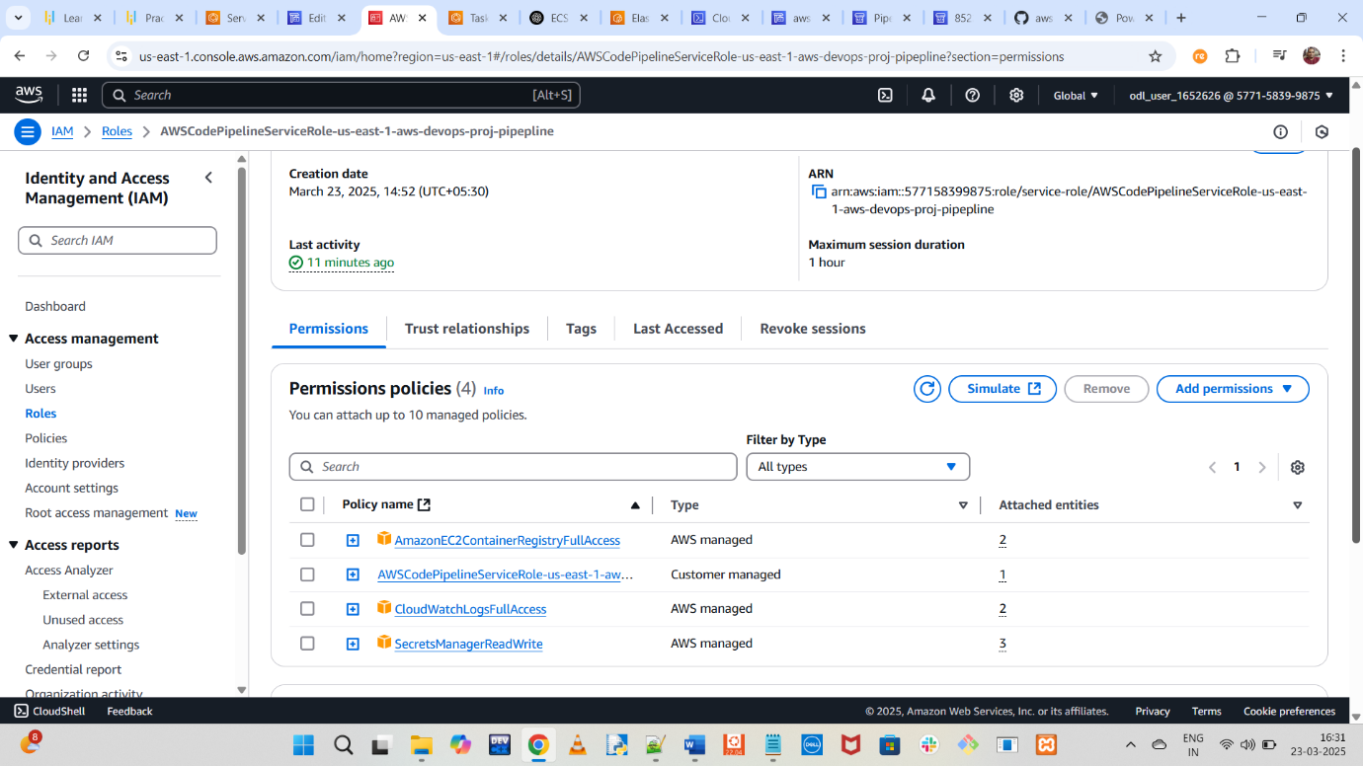

7. Test and monitor the pipeline execution in AWS CodePipeline

